Manjunath Karamudi
Somashekar
 | 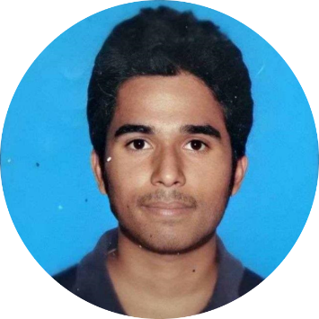
   | Near Govt. School ,vidya nagar IB, Karnataka, 583232
   | 7892215418
   | manjusk017@gmail.com
October 18, 2022
RE: Enthusiastic and Hard-Working (Software Developer)
Dear Hiring Professional,
As a recent graduate from S.K.S.V.M.A.C.E.T, Laxmeshwar with a Bachelor of Engineering in Computer Science, I am extremely interested in the Software Developer opportunity posted on the Your Company website. After reviewing the key qualifications for this role, I am confident that I am well-prepared to be a valuable asset to the company growth and success.
Throughout my academic journey, I applied a strong focus on building my programming and software development abilities, it was Hard Initially(As someone from Non-CS PUC Background) but i took it as a Challenge. I am mainly oriented in Learning new Tech. and application of Those Knowledge . I work best in roles which involves Development of Software , and also allows me to make a positive impact while using Critical problem-solving, Decision-making to resolve issues and achieve Targeted Goals.
As you review my resume, you may notice 1 year gap in my Job Search. I had Personal Things to take care of . While managing the logistics of my family Responsibility, I studied industry news, trends and events to keep my knowledge current. I am now settled and prepared to take the next steps in my career. I hope i can get an Opportunity to execute my Skills, to be a Contributor to Org. Success and Learn a lot in the journey.
My academic strengths have greatly contributed to the development of my critical thinking, decision-making and teamwork skills. I bring clear and effective communication to build professional connections with co-workers, management and customers. I would welcome the opportunity to further discuss the details of my experience and attributes which I believe will be an asset to the Any team. Please review my attached resume for additional insight into my background. Thank you for your time and consideration.
Sincerely,
Manjunath Karamudi

